IPL ASSIGNMENT

What exactly I have done?

I have collected IPL i.e., Indian Premier League data from 2008 to 2020 and made an analysis on the data collected.

Who are the stakeholders/audience?

Team sponsors, team coaches, captains, advertisers, investors.

Why this data was collected in first place?

To sort out strategy for investors to buy players for a team, analyse a player’s efficiency from historical data.

What questions I am trying to answer?

Following are some questions that I am trying to answer;

Q. Total matches played in each season

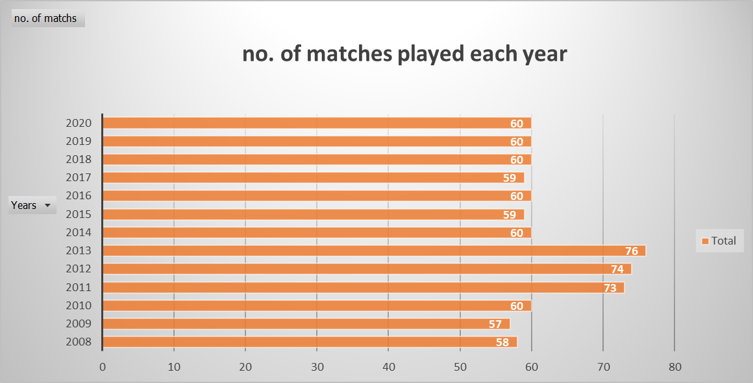

Most toss winners:

|  |  |  |  |  |  |  |  |  |  |  |  |  |  |  |  |
| --- | --- | --- | --- | --- | --- | --- | --- | --- | --- | --- | --- | --- | --- | --- | --- |
| **toss winers** | **season** |  |  |  |  |  | |  |  |  |  |  |  |  |  |
| **teams** | **2008** | **2009** | **2010** | **2011** | **2012** | **2013** | **2014** | | **2015** | **2016** | **2017** | **2018** | **2019** | **2020** | **Grand Total** |
| Mumbai Indians | 8 | 6 | 9 | 6 | 11 | 12 | 6 | | 7 | 9 | 11 | 5 | 8 | 8 | 106 |
| Kolkata Knight Riders | 6 | 7 | 7 | 7 | 7 | 12 | 9 | | 8 | 6 | 9 | 9 | 5 | 6 | 98 |
| Chennai Super Kings | 5 | 7 | 10 | 9 | 7 | 8 | 10 | | 10 |  |  | 11 | 12 | 8 | 97 |
| Rajasthan Royals | 11 | 4 | 6 | 7 | 10 | 11 | 8 | | 6 |  |  | 6 | 11 | 7 | 87 |
| Royal Challengers Bangalore | 5 | 8 | 6 | 6 | 6 | 5 | 9 | | 10 | 6 | 9 | 7 | 4 | 6 | 87 |
| Kings XI Punjab | 8 | 6 | 5 | 10 | 8 | 7 | 7 | | 7 | 6 | 4 | 7 | 6 | 4 | 85 |
| Delhi Daredevils | 6 | 9 | 8 | 9 | 10 | 5 | 4 | | 5 | 8 | 8 | 8 |  |  | 80 |
| Sunrisers Hyderabad |  |  |  |  |  | 7 | 7 | | 6 | 10 | 5 | 7 | 4 | 11 | 57 |
| Deccan Chargers | 9 | 10 | 9 | 6 | 9 |  |  | |  |  |  |  |  |  | 43 |
| Delhi Capitals |  |  |  |  |  |  |  | |  |  |  |  | 10 | 10 | 20 |
| Pune Warriors |  |  |  | 5 | 6 | 9 |  | |  |  |  |  |  |  | 20 |
| Gujarat Lions |  |  |  |  |  |  |  | |  | 8 | 7 |  |  |  | 15 |
| Kochi Tuskers Kerala |  |  |  | 8 |  |  |  | |  |  |  |  |  |  | 8 |
| Rising Pune Supergiants |  |  |  |  |  |  |  | |  | 7 |  |  |  |  | 7 |
| Rising Pune Supergiant |  |  |  |  |  |  |  | |  |  | 6 |  |  |  | 6 |
| **Grand Total** | **58** | **57** | **60** | **73** | **74** | **76** | **60** | | **59** | **60** | **59** | **60** | **60** | **60** | **816** |

**Most Wins in IPL**

|  |  |  |  |  |  |  |  |  |  |  |  |  |  |  |
| --- | --- | --- | --- | --- | --- | --- | --- | --- | --- | --- | --- | --- | --- | --- |
| **most wins** | **season** |  |  |  |  |  |  |  |  |  |  |  |  |  |
| **teams** | **2008** | **2009** | **2010** | **2011** | **2012** | **2013** | **2014** | **2015** | **2016** | **2017** | **2018** | **2019** | **2020** | **Grand Total** |
| Mumbai Indians | 7 | 5 | 11 | 10 | 10 | 13 | 7 | 10 | 7 | 12 | 6 | 11 | 11 | 120 |
| Chennai Super Kings | 9 | 8 | 9 | 11 | 10 | 12 | 10 | 10 |  |  | 11 | 10 | 6 | 106 |
| Kolkata Knight Riders | 6 | 3 | 7 | 8 | 12 | 6 | 11 | 7 | 8 | 9 | 9 | 6 | 7 | 99 |
| Royal Challengers Bangalore | 4 | 9 | 8 | 10 | 8 | 9 | 5 | 8 | 9 | 3 | 6 | 5 | 7 | 91 |
| Kings XI Punjab | 10 | 7 | 4 | 7 | 8 | 8 | 12 | 3 | 4 | 7 | 6 | 6 | 6 | 88 |
| Rajasthan Royals | 13 | 6 | 6 | 6 | 7 | 11 | 7 | 7 |  |  | 7 | 5 | 6 | 81 |
| Delhi Daredevils | 7 | 10 | 7 | 4 | 11 | 3 | 2 | 5 | 7 | 6 | 5 |  |  | 67 |
| Sunrisers Hyderabad |  |  |  |  |  | 10 | 6 | 7 | 11 | 8 | 10 | 6 | 8 | 66 |
| Deccan Chargers | 2 | 9 | 8 | 6 | 4 |  |  |  |  |  |  |  |  | 29 |
| Delhi Capitals |  |  |  |  |  |  |  |  |  |  |  | 10 | 9 | 19 |
| Gujarat Lions |  |  |  |  |  |  |  |  | 9 | 4 |  |  |  | 13 |
| Pune Warriors |  |  |  | 4 | 4 | 4 |  |  |  |  |  |  |  | 12 |
| Rising Pune Supergiant |  |  |  |  |  |  |  |  |  | 10 |  |  |  | 10 |
| Kochi Tuskers Kerala |  |  |  | 6 |  |  |  |  |  |  |  |  |  | 6 |
| Rising Pune Supergiants |  |  |  |  |  |  |  |  | 5 |  |  |  |  | 5 |
| NA |  |  |  | 1 |  |  |  | 2 |  |  |  | 1 |  | 4 |
| **Grand Total** | **58** | **57** | **60** | **73** | **74** | **76** | **60** | **59** | **60** | **59** | **60** | **60** | **60** | **816** |

**Toss decisions:**

|  |  |  |  |  |  |  |  |  |  |  |  |  |  |  |
| --- | --- | --- | --- | --- | --- | --- | --- | --- | --- | --- | --- | --- | --- | --- |
| toss decision | Season |  |  |  |  |  |  |  |  |  |  |  |  |  |
| Category | **2008** | **2009** | **2010** | **2011** | **2012** | **2013** | **2014** | **2015** | **2016** | **2017** | **2018** | **2019** | **2020** | **Grand Total** |
| bat | 26 | 35 | 39 | 25 | 37 | 45 | 19 | 25 | 11 | 11 | 10 | 10 | 27 | 320 |
| field | 32 | 22 | 21 | 48 | 37 | 31 | 41 | 34 | 49 | 48 | 50 | 50 | 33 | 496 |
| Grand Total | **58** | **57** | **60** | **73** | **74** | **76** | **60** | **59** | **60** | **59** | **60** | **60** | **60** | **816** |

Average and percentage of toss decisions throughout the season;

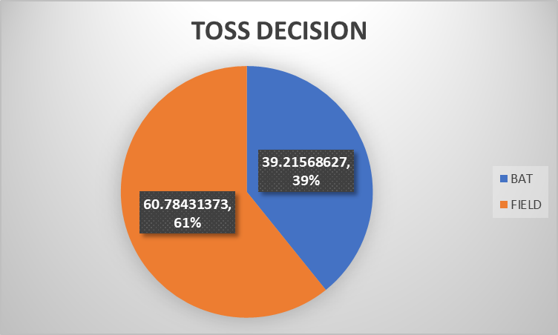

|  |  |  |
| --- | --- | --- |
|  | BAT | FIELD |
| Average | 24.61538462 | 38.2 |
| Percentage (%) | 39.21568627 | 60.8 |

**FAMOUS VENUES:**

|  |  |  |  |  |  |  |  |  |  |  |  |  |  |  |
| --- | --- | --- | --- | --- | --- | --- | --- | --- | --- | --- | --- | --- | --- | --- |
| **FAMOUS VENUES** | **SEASONS** |  |  |  |  |  |  |  |  |  |  |  |  |  |
|  | **2008** | **2009** | **2010** | **2011** | **2012** | **2013** | **2014** | **2015** | **2016** | **2017** | **2018** | **2019** | **2020** | **Grand Total** |
| **Eden Gardens** | **7** |  | **7** | **7** | **7** | **8** | **4** | **7** | **7** | **7** | **9** | **7** |  | **77** |
| **Feroz Shah Kotla** | **6** |  | **7** | **7** | **8** | **8** | **5** | **5** | **7** | **7** | **7** | **7** |  | **74** |
| **Wankhede Stadium** | **6** |  |  | **9** | **8** | **8** | **6** | **8** | **4** | **8** | **9** | **7** |  | **73** |
| **M Chinnaswamy Stadium** | **7** |  | **7** | **6** | **8** | **8** | **6** | **7** | **9** | **7** |  |  |  | **65** |
| **Rajiv Gandhi International Stadium, Uppal** | **7** |  |  | **7** | **4** | **8** | **4** | **4** | **7** | **8** | **7** | **8** |  | **64** |
| **MA Chidambaram Stadium, Chepauk** | **7** |  | **7** | **9** | **10** | **8** |  | **7** |  |  | **1** | **8** |  | **57** |
| **Sawai Mansingh Stadium** | **7** |  | **3** | **7** | **8** | **8** |  |  |  |  | **7** | **7** |  | **47** |
| **Punjab Cricket Association Stadium, Mohali** | **7** |  | **5** | **4** | **6** | **6** | **3** | **4** |  |  |  |  |  | **35** |
| **Dubai International Cricket Stadium** | |  |  |  |  |  | **7** |  |  |  |  |  | **26** | **33** |
| **Sheikh Zayed Stadium** |  |  |  |  |  |  | **7** |  |  |  |  |  | **22** | **29** |
| **Punjab Cricket Association IS Bindra Stadium, Mohali** | | |  |  |  |  |  |  | **7** | **4** | **3** | **7** |  | **21** |
| **Maharashtra Cricket Association Stadium** | |  |  |  |  |  |  | **4** | **4** | **7** | **6** |  |  | **21** |
| **Sharjah Cricket Stadium** |  |  |  |  |  |  | **6** |  |  |  |  |  | **12** | **18** |
| **Dr DY Patil Sports Academy** | **4** |  | **6** | **7** |  |  |  |  |  |  |  |  |  | **17** |
| **Subrata Roy Sahara Stadium** |  |  |  |  | **9** | **8** |  |  |  |  |  |  |  | **17** |
| **Kingsmead** |  | **15** |  |  |  |  |  |  |  |  |  |  |  | **15** |
| **M.Chinnaswamy Stadium** |  |  |  |  |  |  |  |  |  | **1** | **7** | **7** |  | **15** |
| **Dr. Y.S. Rajasekhara Reddy ACA-VDCA Cricket Stadium** | | |  |  | **2** |  |  | **3** | **6** |  |  | **2** |  | **13** |
| **Sardar Patel Stadium, Motera** |  |  | **4** |  |  |  | **4** | **4** |  |  |  |  |  | **12** |
| **SuperSport Park** |  | **12** |  |  |  |  |  |  |  |  |  |  |  | **12** |
| **Brabourne Stadium** |  |  | **7** |  |  |  | **1** | **3** |  |  |  |  |  | **11** |
| **Saurashtra Cricket Association Stadium** | |  |  |  |  |  |  |  | **5** | **5** |  |  |  | **10** |
| **Himachal Pradesh Cricket Association Stadium** | |  | **2** | **3** | **2** | **2** |  |  |  |  |  |  |  | **9** |
| **Holkar Cricket Stadium** |  |  |  | **2** |  |  |  |  |  | **3** | **4** |  |  | **9** |
| **New Wanderers Stadium** |  | **8** |  |  |  |  |  |  |  |  |  |  |  | **8** |
| **St George's Park** |  | **7** |  |  |  |  |  |  |  |  |  |  |  | **7** |
| **Barabati Stadium** |  |  | **2** |  | **2** |  | **3** |  |  |  |  |  |  | **7** |
| **Newlands** |  | **7** |  |  |  |  |  |  |  |  |  |  |  | **7** |
| **JSCA International Stadium Complex** | |  |  |  |  | **2** | **4** | **1** |  |  |  |  |  | **7** |
| **Shaheed Veer Narayan Singh International Stadium** | | |  |  |  | **2** |  | **2** | **2** |  |  |  |  | **6** |
| **Nehru Stadium** |  |  |  | **5** |  |  |  |  |  |  |  |  |  | **5** |
| **Green Park** |  |  |  |  |  |  |  |  | **2** | **2** |  |  |  | **4** |
| **Vidarbha Cricket Association Stadium, Jamtha** | |  | **3** |  |  |  |  |  |  |  |  |  |  | **3** |
| **De Beers Diamond Oval** |  | **3** |  |  |  |  |  |  |  |  |  |  |  | **3** |
| **Buffalo Park** |  | **3** |  |  |  |  |  |  |  |  |  |  |  | **3** |
| **OUTsurance Oval** |  | **2** |  |  |  |  |  |  |  |  |  |  |  | **2** |
| **Grand Total** | **58** | **57** | **60** | **73** | **74** | **76** | **60** | **59** | **60** | **59** | **60** | **60** | **60** | **816** |

**MOST WINS IN ELIMINATOR:**

|  |  |  |  |  |  |  |  |  |  |  |  |  |  |  |
| --- | --- | --- | --- | --- | --- | --- | --- | --- | --- | --- | --- | --- | --- | --- |
| TEAMS | SEASONS |  |  |  |  |  |  |  |  |  |  |  |  |  |
|  | **2008** | **2009** | **2010** | **2011** | **2012** | **2013** | **2014** | **2015** | **2016** | **2017** | **2018** | **2019** | **2020** | **Grand Total** |
| Chennai Super Kings | **9** | **8** | **9** | **11** | **10** | **12** | **10** | **10** |  |  | **11** | **10** | **6** | **106** |
| N | 9 | 8 | 9 | 11 | 10 | 12 | 10 | 10 |  |  | 11 | 10 | 6 | 106 |
| Deccan Chargers | **2** | **9** | **8** | **6** | **4** |  |  |  |  |  |  |  |  | **29** |
| N | 2 | 9 | 8 | 6 | 4 |  |  |  |  |  |  |  |  | 29 |
| Delhi Capitals |  |  |  |  |  |  |  |  |  |  |  | **10** | **9** | **19** |
| N |  |  |  |  |  |  |  |  |  |  |  | 9 | 8 | 17 |
| Y |  |  |  |  |  |  |  |  |  |  |  | 1 | 1 | 2 |
| Delhi Daredevils | **7** | **10** | **7** | **4** | **11** | **3** | **2** | **5** | **7** | **6** | **5** |  |  | **67** |
| N | 7 | 10 | 7 | 4 | 11 | 3 | 2 | 5 | 7 | 6 | 5 |  |  | 67 |
| Gujarat Lions |  |  |  |  |  |  |  |  | **9** | **4** |  |  |  | **13** |
| N |  |  |  |  |  |  |  |  | 9 | 4 |  |  |  | 13 |
| Kings XI Punjab | **10** | **7** | **4** | **7** | **8** | **8** | **12** | **3** | **4** | **7** | **6** | **6** | **6** | **88** |
| N | 10 | 7 | 3 | 7 | 8 | 8 | 12 | 2 | 4 | 7 | 6 | 6 | 5 | 85 |
| Y |  |  | 1 |  |  |  |  | 1 |  |  |  |  | 1 | 3 |
| Kochi Tuskers Kerala |  |  |  | **6** |  |  |  |  |  |  |  |  |  | **6** |
| N |  |  |  | 6 |  |  |  |  |  |  |  |  |  | 6 |
| Kolkata Knight Riders | **6** | **3** | **7** | **8** | **12** | **6** | **11** | **7** | **8** | **9** | **9** | **6** | **7** | **99** |
| N | 6 | 3 | 7 | 8 | 12 | 6 | 11 | 7 | 8 | 9 | 9 | 6 | 6 | 98 |
| Y |  |  |  |  |  |  |  |  |  |  |  |  | 1 | 1 |
| Mumbai Indians | **7** | **5** | **11** | **10** | **10** | **13** | **7** | **10** | **7** | **12** | **6** | **11** | **11** | **120** |
| N | 7 | 5 | 11 | 10 | 10 | 13 | 7 | 10 | 7 | 11 | 6 | 10 | 11 | 118 |
| Y |  |  |  |  |  |  |  |  |  | 1 |  | 1 |  | 2 |
| NA |  |  |  | **1** |  |  |  | **2** |  |  |  | **1** |  | **4** |
| NA |  |  |  | 1 |  |  |  | 2 |  |  |  | 1 |  | 4 |
| Pune Warriors |  |  |  | **4** | **4** | **4** |  |  |  |  |  |  |  | **12** |
| N |  |  |  | 4 | 4 | 4 |  |  |  |  |  |  |  | 12 |
| Rajasthan Royals | **13** | **6** | **6** | **6** | **7** | **11** | **7** | **7** |  |  | **7** | **5** | **6** | **81** |
| N | 13 | 5 | 6 | 6 | 7 | 11 | 6 | 7 |  |  | 7 | 5 | 6 | 79 |
| Y |  | 1 |  |  |  |  | 1 |  |  |  |  |  |  | 2 |
| Rising Pune Supergiant |  |  |  |  |  |  |  |  |  | **10** |  |  |  | **10** |
| N |  |  |  |  |  |  |  |  |  | 10 |  |  |  | 10 |
| Rising Pune Supergiants |  |  |  |  |  |  |  |  | **5** |  |  |  |  | **5** |
| N |  |  |  |  |  |  |  |  | 5 |  |  |  |  | 5 |
| Royal Challengers Bangalore | **4** | **9** | **8** | **10** | **8** | **9** | **5** | **8** | **9** | **3** | **6** | **5** | **7** | **91** |
| N | 4 | 9 | 8 | 10 | 8 | 8 | 5 | 8 | 9 | 3 | 6 | 5 | 6 | 89 |
| Y |  |  |  |  |  | 1 |  |  |  |  |  |  | 1 | 2 |
| Sunrisers Hyderabad |  |  |  |  |  | **10** | **6** | **7** | **11** | **8** | **10** | **6** | **8** | **66** |
| N |  |  |  |  |  | 9 | 6 | 7 | 11 | 8 | 10 | 6 | 8 | 65 |
| Y |  |  |  |  |  | 1 |  |  |  |  |  |  |  | 1 |
| Grand Total | **58** | **57** | **60** | **73** | **74** | **76** | **60** | **59** | **60** | **59** | **60** | **60** | **60** | **816** |

**here 'Y' means played eliminator & 'N' means not played eliminator**

**Kings XI Punjab has wined most eliminator matches i.e., 3**

**MOST RUNS MADE BY PLAYERS:**

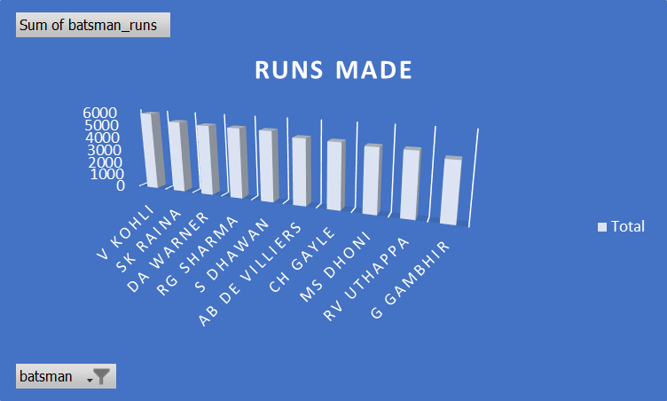(TOP 10 PLAYERS)

|  |  |
| --- | --- |
| **Batsman** | **Sum of batsman_runs** |
| V Kohli | 5878 |
| SK Raina | 5368 |
| DA Warner | 5254 |
| RG Sharma | 5230 |
| S Dhawan | 5197 |
| AB de Villiers | 4849 |
| CH Gayle | 4772 |
| MS Dhoni | 4632 |
| RV Uthappa | 4607 |
| G Gambhir | 4217 |
| **Grand Total** | **50004** |

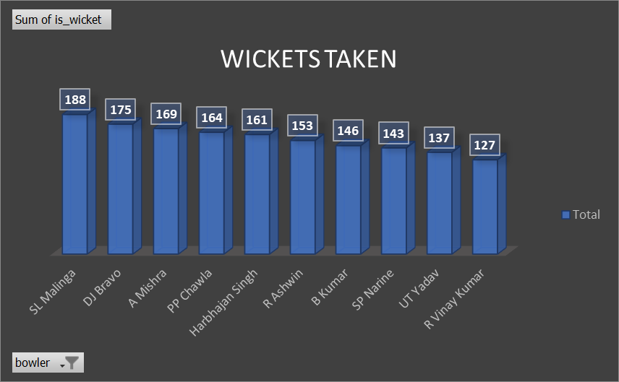MOST WICKETS TAKEN:

|  |  |
| --- | --- |
| **Blowers** | **Sum of is_wicket** |
| SL Malinga | 188 |
| DJ Bravo | 175 |
| A Mishra | 169 |
| PP Chawla | 164 |
| Harbhajan Singh | 161 |
| R Ashwin | 153 |
| B Kumar | 146 |
| SP Narine | 143 |
| UT Yadav | 137 |
| R Vinay Kumar | 127 |
| **Grand Total** | **1563** |